Creating Jekin Job to Build Spring boot project

mvn clean clean or remove old build file

mvn compile compile the maven project

mvn test junit testing

mvn package to jar or war file

mvn install install war or jar file in local repository

**In Jenkin installing custom plugins**

Click on Manage Jenkin

Tools

Adding maven plugin in Jenkin

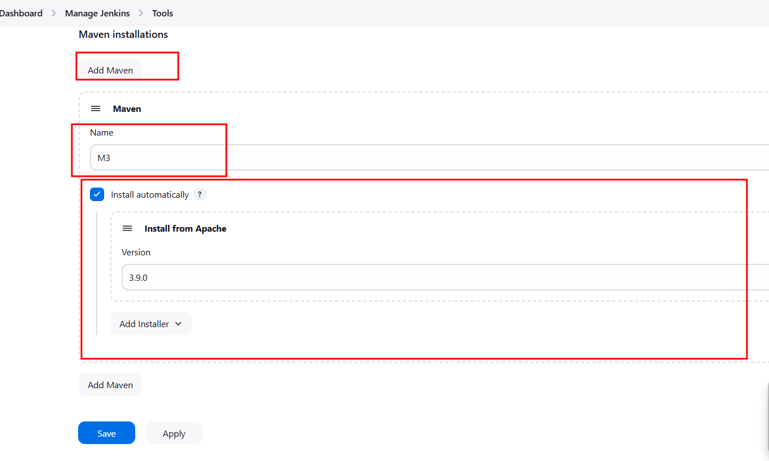

**Jenkin Pipe Line Job**

Jenkin pipe line is used to execute series of command. Those command are interconnected with each other to do specific task. To write these all command we can use Jenkinsfile. Inside this file we write set of instruction.

Creating Jenkin pipe line job to execute custom script file

